Name:________________________________________________Date:____________________________Class________

APWH Notes| Classical India (Pairs with AMSCO 5) Missed Something? www.myhaikuclass.com/mswardo/apwh

Outcomes: At the conclusion of this section, students will have:
- Described the beginnings of civilization and establishment of empires in Classical India
- Outlined the developments of politics, economy, and social structure in Classical India

Big Idea: While China may have been known as the Middle Kingdom, India became known as a subcontinent. Classical India was focused between, and around, two rivers - the Indus and the Ganges - as well as situated south of the Himalayas, and along an important ocean. Unlike China, the people of India were able to utilize their geographic position in the world to their advantage, focusing on trade and outside influences to create a robust, powerful empire. The religious belief systems, languages, and social structure that originated in Classical India are some of the most unique in the world, and have remained influential to this day.

Key Vocabulary:
Ashoka Brahmins Buddhism Caste System Gupta Dynasty
Jainism Kshatriyas Kushan Empire Mauryan Dynasty Shudras
Vaishyas Varnas Untouchables/Dalits

MAIN IDEAS | NOTES
1. ORIGINS  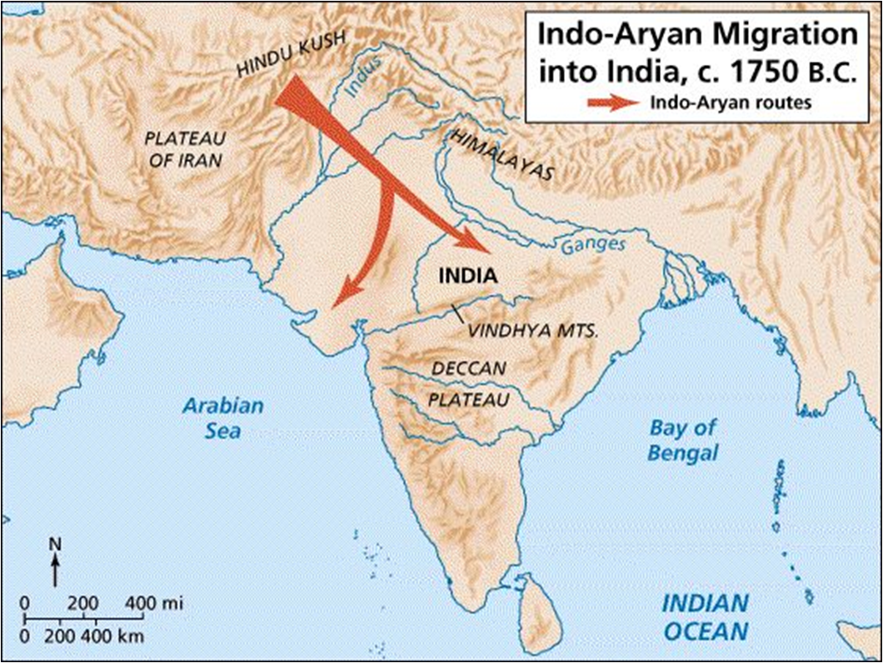  *Keep in Mind:  -Harappa and Mohenjo Daro  -Nomadic Aryans  -Alexander the Great  -Mauryan Dynasty  -Kushans  -Gupta Dynasty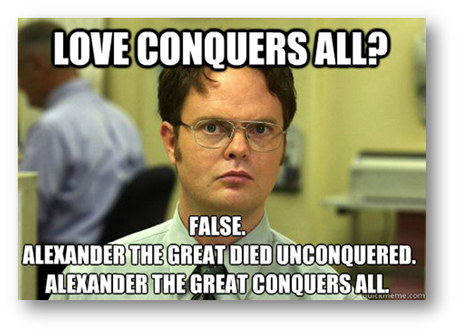 | A. Origins of Classical India after fall of Harappa and Mohenjo Daro  -What happens in 1500 BCE:  -Who moves in a builds a new civilization (1500-500 BCE):  -What is this new civilization based on:  B. Describe the political structure of Classical India BEFORE Alexander the Great  -Similar to:  -Organized by regionalism (what does this mean):  -Common political formats:  -What connects these regions:  -What is very common:  C. Alexander the Great invades (327 BCE)  -Forces leaders to:  -Who seizes power after Alexander the Great:  -What political elements do they borrow from Alexander the Great?
2. Dynastic Changes
A. Mauryan Dynasty
B. Kushans
C. Gupta Dynasty

3. Economic Developments | 4. Technological Developments

5. Social Structure (Triangle on next page to help!)
-Life is based on the: _____________________________________, which is extremely rigid and ________________

-The 5 main classes (varnas) are:

- _____________________: priests
- _____________________: warrior/governing class
- _____________________: traders and farmers
- _____________________: common laborers
- _____________________: also known as Dalit, confined to jobs like hauling trash and dead bodies

-The Caste System is _________________________________, or passed onto children
-Marriage between castes is ___________________________________________________
-The Caste System assigns people their ________________________________________, which is their social identity

-Classical Indian Society is
- _________________________________, husbands and fathers are dominant figures
- Women have ____________________________ political or economic rights
- ___________________________________ are common

Flip Page for Caste System Pyramid

